Xyrus

Your Friendly Virus

Author : John Paul Marte

Date : February 12, 2025

Copyright Information : © 2025 John Paul Marte. All Rights Reserved.

Version 0.1(draft) October 10, 2005

By Mark Baldwin

Baldwin Consulting

http://baldwinconsulting.org

The Game Design Document (GDD) it the blueprint from which a computer or video game is to be built. As such, every single detail necessary to build the game must be addressed in the document (or support documents). If it’s not in the document, then it probably won’t be in the game.

Below you will find an outline for a generic Game Design Document. The problem is that no generic GDD will be able to address all the various genres for which a game may be created. For example, consider the games PacMan, SimCity and Doom. All three games required detailed design documents, but if you think about it, those documents would be entirely different! As such, when using the outline below you will find sections that will be totally meaningless to your game. But also, there will be sections that your GDD requires to describe the game. Just because it’s not in my outline, it doesn’t mean that it doesn’t belong.

The GDD is a reference document. Members of the development team will constantly be using the document to find specific information for their specific needs. Consider the size such a document may grow to in order to document every piece of the game. We don’t want the GDD to cause information overload and then become a prop under somebody’s wobbly desk. As such it is important that you organize and format the document to make it easy to use. Also note that some of these sections might not appear in the GDD itself but instead would appear in supplemental documents such as an Art Bible or Test Plan. This helps make the overall document more manageable and readable.

One last comment, a game design document is meant to be a living document. Just as when the artist changes the design of his painting every time he takes his brush to the canvas, a computer or video game evolves as code and art are created. The GDD then is the communication tool from which all the members of the team can follow that evolution.

**Document Revision history:**

|  |  |  |  |
| --- | --- | --- | --- |
| Version | Date | Author(s) | Changes |
| 0.1 | Jan .18, 2025 | Paul Marte | Initial GDD |
| 0.2 | Feb.12, 2025 | Paul Marte | Draft 2 |
|  |  |  |  |

*(Use word’s “update table of contents” to generate / regenerate a table of contents. )*

Table of Contents

1. Section I - Game Overview 6

1.1. Game Concept 6

1.2. Design History 6

1.3. Feature Set 6

1.4. Genre 6

1.5. Target Audience 6

1.6. Game Flow Summary 6

1.7. Look and Feel 6

1.8. Project Scope 7

1.8.1. Number of locations 7

1.8.2. Number of levels 7

1.8.3. Number of NPC’s 7

1.8.4. Number of weapons 7

2. Section II - Gameplay and Mechanics 7

2.1. Gameplay 7

2.1.1. Game Progression 7

2.1.2. Mission/challenge Structure 7

2.1.3. Puzzle Structure 7

2.1.4. Objectives – What are the objectives of the game? 7

2.1.5. Play Flow – How does the game flow for the game player 7

2.2. Mechanics 7

2.2.1. Physics 7

2.2.2. Movement 8

2.2.3. Objects 8

2.2.4. Actions 8

2.2.5. Combat 8

2.2.6. Economy 8

2.3. Screen Flow 9

2.3.1. Screen Flow Chart 9

2.3.2. Screen Descriptions 9

2.4. Game Options 9

2.5. Cheats and Easter Eggs 9

3. Section III – Story, Setting and Character 9

3.1. Story and Narrative 9

3.1.1. Back story 9

3.1.2. Plot Elements 9

3.2. Game World 9

3.2.1. General look and feel of world 9

3.3. Characters 10

3.3.1. Character #1 10

3.3.2. Character #2 10

4. Section V - Interface 11

4.1. Visual System 11

4.1.1. HUD - What controls 11

4.1.2. Menus 11

4.2. Control System 11

4.3. Music 11

4.4. Sound Effects 11

5. Section VI - Artificial Intelligence 11

5.1. Opponent AI 11

5.2. Enemy AI 11

6. Section VII – Technical 12

6.1. Target Hardware and operating system 12

6.2. Supported game controllers and peripherals 12

7. Section VIII – Game Art 12

7.1. Concept Art 12

7.2. Style Guides 12

7.3. Characters 12

7.4. Environments 13

7.5. Equipment 13

# Section I - Game Overview

## Game Concept

**Xyrus**, Your Friendly Virus is a fast-paced, top-down 2D arcade game where players control a friendly virus named Xyrus. The goal is to infect areas to make them immune to harmful viruses while avoiding threats like white blood cells. Players use strategic movement and unique abilities, such as teleportation, to outmaneuver these threats.

## Design History

Version 1.0 : Core infection and avoidance mechanics established.

Version 1.1 : Progressive spawning of white blood cells

Version 1.2 : Teleportation Slime mechanic & mobility

Version 1.3 : Optional capsule or tablet infection clearing mechanics added.

## Feature Set

Real-time infection mechanics.

Unique teleportation ability using a slime projectile.

Increasing difficulty with more white blood cells and potential infection clearing mechanics.

## Genre

Tactical Arcade/Action Puzzle

## Target Audience

Casual gamers, fans of arcade-style games, ages 10 and above.

Gamers that are in the medical field or bioscience.

## Game Flow Summary

Players control Xyrus using directional keys, strategically infecting areas and avoiding white blood cells. The teleportation slime adds a layer of strategic mobility. Optional capsules introduce additional challenges by clearing infected zones and potentially ending the game. Players win by infecting all designated zones and lose if collided with white blood cells.

## Look and Feel

Biological, with stylized representations of white blood cells and viruses. Lighthearted and fast-paced. Minimalist with vibrant colors to represent infection zones, hazards, and player actions.

## Project Scope

### Number of locations

Single "window" environment.

### Number of levels

2 progressively challenging levels.

### Number of NPC’s

None (hazards are non-sentient objects).

### Number of weapons

None

# Section II - Gameplay and Mechanics

## Gameplay

### Game Progression

Players progress through levels with increasing hazard density and complexity.

### Mission/challenge Structure

Infect all areas of the window while avoiding white blood cells and capsules.

### Puzzle Structure

Strategic placement of infected zones and effective use of teleportation slime to navigate around threats.

### Objectives – What are the objectives of the game?

Infect all designated areas.

Avoid collision with white blood cells and capsules.

### Play Flow – How does the game flow for the game player

Players alternate between infection strategy and quick reflex-based navigation.

## Mechanics

### Physics

White blood cells bounce dynamically off walls with randomized velocity changes.

Slime moves in a straight line toward the clicked position.

### Movement

#### General Movement

Xyrus Movement: Controlled with W, A, S, D keys. Cannot leave the screen boundaries.

Slime Movement: Fired toward the mouse pointer with a left click.

#### Other Movement

Teleportation: Triggered by pressing 'R' while the slime is active.

### Objects

#### Picking Up Objects

None

#### Moving Objects

Infected Areas: Created by pressing the spacebar.

White Blood Cells: Move randomly and bounce off walls.

Capsules (Optional): Move horizontally or vertically, clearing infections and killing Xyrus on contact.

### Actions

#### Switches and Buttons

Infection: Press spacebar to infect Xyrus's current position.

Slime Firing: Left click to fire slime.

Teleportation: Press 'R' to teleport to the slime's position.

#### Picking Up, Carrying and Dropping

None

#### Talking

None

#### Reading

None

### Combat

No combat; the challenge is in avoiding hazards and maintaining infection progress.

### Economy

None

## Screen Flow

### Screen Flow Chart

TO BE GENERATED

### Screen Descriptions

#### Main Menu Screen

Start Game, Options, Exit.

#### Options Screen

Game Option.

## Game Options

Adjust difficulty settings and enable/disable capsule hazards.

## Cheats and Easter Eggs

None

# Section III – Story, Setting and Character

## Story and Narrative

### Back story

Xyrus is a rogue virus programmed to protect against harmful pathogens by infecting zones and making them immune. However, the body's defenses view Xyrus as a threat.

### Plot Elements

Progress through increasingly defended windows to complete the infection cycle.

## Game World

### General look and feel of world

A stylized microscopic environment representing a biological cell.

## Characters

### Character #1

#### Back story

Xyrus is a rogue virus programmed to protect against harmful pathogens by infecting zones and making them immune.

#### Personality

Cheerful and determined.

#### Look

A mischievous entity represented as a corona virus look and color green

##### Physical characteristics

Xyrus is a friendly virus with a mischievous smile.

##### Animations

Smiling and Happy

#### Special Abilities

Teleportation slime

#### Relevance to game story

Main character

#### Relationship to other characters

Unwanted by white blood cells

### Character #2

#### Back story

White blood cells are the defenders of the body. It attacks foreign objects that enter the body, i.e., viruses.

#### Personality

Anxious, constantly moving and attacking.

#### Look

An anxious entity represented as a corona virus look and color grey

##### Physical characteristics

Corona virus looks and color grey

##### Animations

Confused

#### Special Abilities

#### Relevance to game story

Defenders of the body

#### Relationship to other characters

Mistakenly treating Xyrus as enemy

# Section V - Interface

## Visual System

### HUD - What controls

Progress bar for infection

### Menus

Simplistic design focusing on quick navigation.

## Control System

Keyboard inputs for movement, teleportation, and interaction.

## Music

Upbeat and dynamic.

## Sound Effects

Feedback for infections, teleportation, and collisions.

# Section VI - Artificial Intelligence

## Opponent AI

No strategic AI; hazards operate on randomized movement patterns.

## Enemy AI

N/A (hazards are pre-programmed objects).

# Section VII – Technical

## Target Hardware and operating system

PC / Windows

## Supported game controllers and peripherals

Keyboard and mouse

# Section VIII – Game Art

## Concept Art

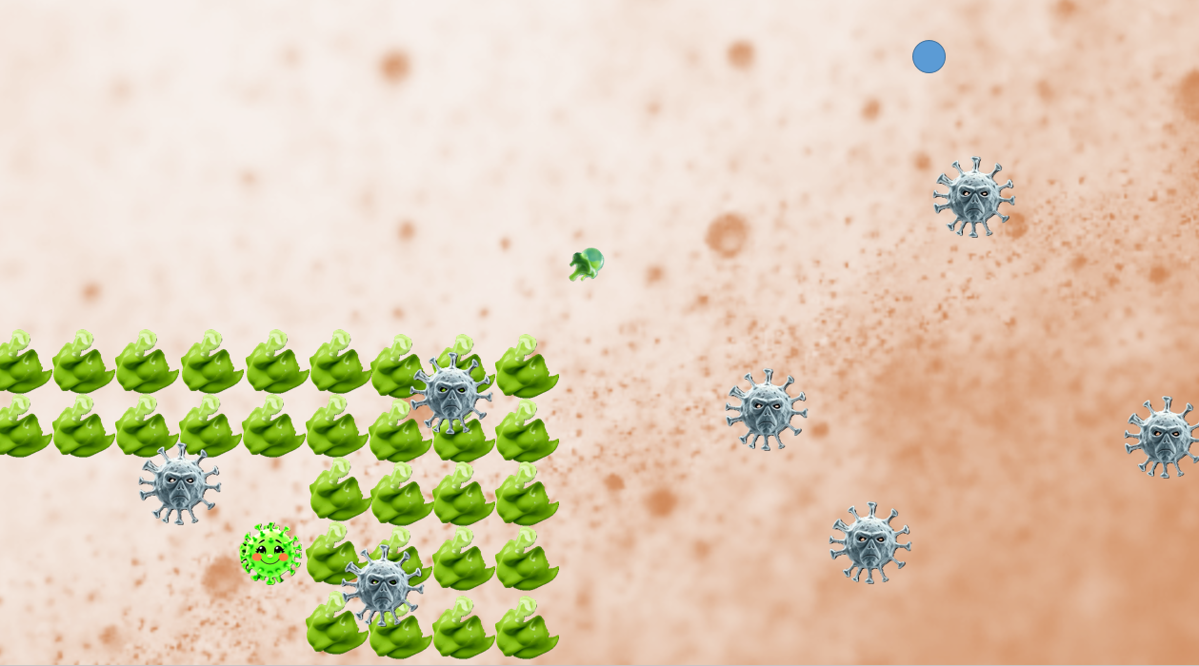

## Style Guides

## Characters

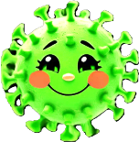 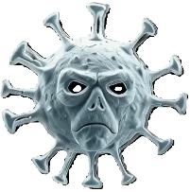

XYRUS WHITE BLOOD CELL

## Environments



MICROSCOPIC VIEW

## Equipment

 

TELEPORATION SLIME INFECTED AREA